**LATE SUMMER KALE SALAD WITH MISO-TAHINI DRESSING**

Dressing Ingredients:

* 2 tbs. sweet white or yellow miso
* 1 1/2 tbs. tahini (sesame seed paste)
* 1 1/2 tbs. maple syrup (Grade B – The real stuff)
* 2 tbs. seasoned rice vinegar
* 1 tbs. grapeseed oil or extra virgin olive oil
* 1/4 tsp. ground coriander
* pinch cayenne pepper
* pinch cracked black pepper

[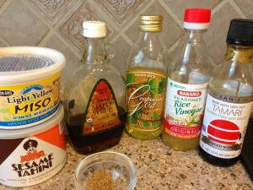](http://click.icptrack.com/icp/relay.php?r=21540637&msgid=250266&act=E635&c=1038980&destination=http%3A%2F%2Furockgirl.com%2Furg%2Fwp-content%2Fuploads%2F2013%2F09%2FMISO-TAHINI-DRESSING-INGREDIENTS.jpg)

Salad Ingredients:

* 3 cups organic green kale
* 3 cups organic purple or red kale
* 1/2 sweet white or yellow onion
* 1/3 cup grated carrot
* 1 small yellow or red bell pepper, seeded and chopped
* 3 persian cucumbers, chopped

[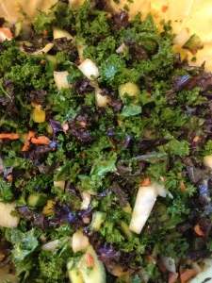](http://click.icptrack.com/icp/relay.php?r=21540637&msgid=250266&act=E635&c=1038980&destination=http%3A%2F%2Furockgirl.com%2Furg%2Fwp-content%2Fuploads%2F2013%2F09%2FKALE-SALAD-WITH-MISO-DRESSING.jpg)

Directions:

1. Whisk all dressing ingredients in a bowl until smooth. Set aside
2. Chop the kale until small pieces (this will help to tenderize the kale a bit); place in a very large mixing bowl. Add all of the other vegetables and toss with your hands.
3. Now the fun part! Pour the dressing over the salad and use your hands to*massage*, yes I said massage, the dressing into the kale and all of the vegetables. This will help soften the kale and evenly distribute the dressing. Massgae for about 2 minutes.

Note: You can serve right away or cover with plastic wrap and let it sit in the fridge for a few hours or even a day. The kale will continue to soften while it sits in the dressing.

[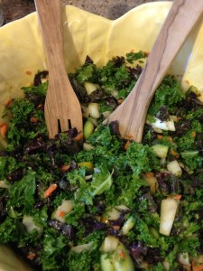](http://click.icptrack.com/icp/relay.php?r=21540637&msgid=250266&act=E635&c=1038980&destination=http%3A%2F%2Furockgirl.com%2Furg%2Fwp-content%2Fuploads%2F2013%2F09%2FKALE-SALAD.jpg)

http://feeds.feedburner.com/~r/URockGirl/~4/ObnQoSZMtOA?utm_source=feedburner&utm_medium=email